Guidelines for the Design Documents
(PDR, CDR, FDR)

(replace the title of the document with your own title e.g. “team name CanSat Preliminary Design Review”)

Team Name:

Country:

The process of building a satellite is very complex and costly. That is why, in a real satellite mission, there are some documents that have to be delivered before, during and after the satellite is built. These documents serve to provide detailed information about the satellite being developed and to ensure that it complies with all the requirements regarding the mission and the launch environment.

The process of designing and building a CanSat is much simpler than the one followed for a satellite. Nevertheless, we believe that exposing students to good engineering procedures will be very beneficial for their educational experience.

These guidelines provide information about the expected content of each chapter. This information will ensure that the work you are doing is aligned with your mission goals and it can help us to identify possible problems at an early stage. It will also help us to determine that your CanSat will be able to fly according to the mechanical and safety requirements.

Attached to this document there is a blank design document with a given structure that you can modify to describe all the aspects of your CanSat project. There is no limit to the number of pages used but it should be well-structured and appendices should be used for detailed information to keep the main body of the document as concise as possible. This detailed information may be e.g. details of scientific background, technical drawings or component datasheets. The documentation should be written in a clear and concise manner that allows a person who does not know the experiment to understand its purpose and design.

The design document should provide ESA and ESERO with all important information on the experiment. During all experiment phases the design document is the only documentation for describing the experiment in detail. The chapters can be modified and additional sections can be added by the experiment team if appropriate. The design document will be one of the evaluating criteria for the jury of the European CanSat competition.

Table of Contents
1 CHANGELOG 4
2 INTRODUCTION 5
2.1 Team organisation and roles 5
2.2 Mission objectives 5
3 Cansat Description 6
3.1 Mission overview 6
3.2 Mechanical/structural design 7
3.3 Electrical design 8
3.3.1 General architecture 8
3.3.2 Primary mission devices 8
3.3.3 Secondary mission devices 8
3.3.4 Power supply 8
3.3.5 Communication system 9
3.4 Software design 9
3.5 Recovery system 9
3.6 Ground support Equipment 10
4 TEST CAMPAIGN 11
4.1 Primary mission tests 11
4.2 Secondary mission tests 11
4.3 Tests of recovery system 11
4.4 Communication system range tests 11
4.5 Energy budget tests 12
5 Project Planning 13
5.1 Time schedule 13
5.2 Task list 13
5.3 Resource estimation 14
5.3.1 Budget 14
5.3.2 External support 14
outreach programme 15
6 CanSat characteristics 16

CHANGELOG

The aim of the change log is to indicate the most important changes in mission definition, realisation and CanSat design.

It should have a form of concise list of changes – the list should be appended in each report.

For instance:

PDR

- Secondary mission was reduced – instead of measurement of methane, carbon dioxide and oxygen concentration, a deep investigation of oxygen concentration will be performed.
- Our team has a new member, who will be responsible for mechanical configuration.

CDR
- After tests we’ve decided to use rechargeable li-ion power source instead of single-use batteries.
- We’ve changed our oxygen sensor from XXX model to YYY model in order to gain more reliable measurement.
- GPS module was added to have higher probability of CanSat finding.

FDR

- We’ve improved ground station software to gain ability to see results of primary mission measurements in real time.

INTRODUCTION

Team organisation and roles

Present the teacher, the team members and their respective roles in the team.

Include their:

- Background, path that they are following if applicable (pure sciences, maths, etc) and interests (e.g. physics, computer science, mechanical engineering, etc.).
- Field of work within the team, giving details of tasks
- Expected workload within the team (in general terms)
- Hours dedicated at school, (e.g. 1h per week during physics course)
- Hours dedicated after school

Mission objectives

Describe your secondary mission and the reasons why you selected that mission.

Define which objectives should be reached in order for the CanSat launch to be considered successful.

What result do you expect from your research?

What are you going to measure/investigate/test?

Cansat Description

Mission overview

Give an overview of how the missions will be carried out.

E.g: Design and build a CanSat to be launched and deployed from a rocket at an altitude of about 450 meters. The CanSat is to descend no faster than 4.6 meters per second. Once landed, the CanSat will measure the soil surface temperature and record the data every 5 minutes for two hours minimum.

Please take into account that this definition is just an example and has nothing to do with the real missions that you will perform.

Name the key elements that you will use to accomplish them (e.g. sensors, cameras, materials to be tested).

We are providing you with a block diagram that is not completed; you should fill it in with all the functional and/or physical blocks of the experiment and describe in general terms how these elements interact, without providing any technical detail.

The mission overview should not describe any design choices!

Block diagram:

Microcontroller

Transmitter

Ground Station

Mechanical/structural design

Describe the mechanical design, the material used for the CanSat structure and how every component is rigidly mounted to the structure. Include mechanical drawings and pictures of the CanSat structure and design. Document all your movable parts (if you have any) to make sure that they do not interfere with the rest of the design and document their tests. Make sure that your structure and design is reliable enough to withstand rocket acceleration.

Create a mass budget to estimate overall weight of the CanSat. Try to compare it with the measurement of the parts to make sure that you comply with the regulatory limits.

Electrical design

General architecture

Describe the electrical part of the CanSat. You should use electronic drawings/schematics or block diagrams with proper connections.

Primary mission devices

Provide description of on-board computer, sensors used for primary mission, their basic characteristics and radio communication used.

Secondary mission devices

Describe all electronics things related to secondary mission. Show their functions, describe curtail parameters for realisation of your secondary mission.

Power supply

Provide a power budget, detailing how much power each component consumes and battery capacity. Make an estimation of the power consumption and the life of the CanSat on the batteries. Provide used batteries types and parameters.

Communication system

Describe the usage of the Radio Frequency link. Indicate used transceivers, communication modes (one direction from CanSat to ground station or both directions), CanSat and ground station antenna design.

Software design

Describe the software design of the CanSat and how is expected to work and detail the On-Board Data Handling.

Give a flow diagram of the software program flow. If applicable, describe different software modes.

Estimate the amount of data gathered and discuss its storage on-board the experiment or its transfer to the ground segment.

Indicate what programming language(s) and development environments are used.

You can attach source code of your software as the appendix to the documentation (please do not put it into the document body).

Recovery system

Give a description of the recovery system used. Indicate the estimated flight time (calculated from the theory and compared with the performed tests).
Show the method used to mount your recovery system to the CanSat structure.
You should add a picture of a design.

Ground support Equipment

Describe all equipment that is part of the experiment but that does not fly on the rocket. Usually, this is the ground segment, one or several computers that receive data from the experiment, a radio receiver, etc. Describe the software design of the ground segment and detail the handling of received data.

TEST CAMPAIGN

Primary mission tests

Describe how you’re planning to test ambient temperature sensing and static pressure measurement.

Secondary mission tests

Describe how you’re planning to test your secondary mission. Emphasize your mission objectives in relation to the collected data from the test runs. Depending on the type of the mission you’ve chosen select appropriate testing method for your sensors, data processing algorithms and mission realisation.

Tests of recovery system

Describe how you’re planning to test your recovery system.
Then, perform planned tests. You can use a dummy-mass model instead of your CanSat. Document your tests and note results. Compare your results with theoretical description, include conclusions.

Communication system range tests

Describe planned and performed radio range tests. Make sure to document all the environmental conditions – the test side, document the visibility of the antennas and obstacles in the Fresnel zone. Compare achieved range with the previous year’s distances.

Energy budget tests

Battery life of the primary mission should be tested to increase the chance of CaSat finding. This should be tested in real-mission environment (secondary mission, additional equipment and sensors). Provide the measurements from the performed battery life tests – especially documenting the time when the CanSat stops transmitting data.

Project Planning

Time schedule

Provide a schedule that includes the phases of design, prototyping, construction, testing, and all key dates.

Task list

When creating your task list, try to break complex tasks down into simple ones as much as possible. Shown below is an example of one possible way you could organise your task list. You are free, however, to format your information in another way if you wish.

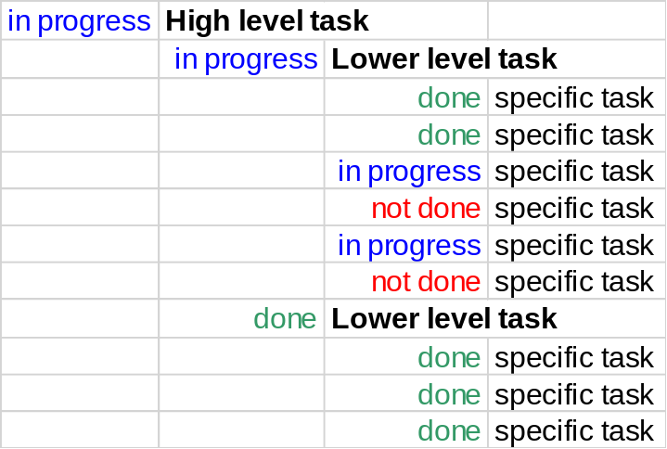

Resource estimation

Budget

List all the foreseen costs of the CanSat in a table form. Make sure that the total budget of your CanSat does not exceed 500€. Include the cost of the CanSat Kit if you use it in your CanSat.

External support

List the organisations, departments or companies that provide sponsorship or in-kind support. For example, professors of a university or institute, local companies or nearby research laboratories, facilities to which access is possible, etc. Mention any support or expertise which is lacking.

outreach programme

Outline the approach to publicising and communicating about your project.

Describe the team’s website or blog and how it is planned to evolve.

Include a summary list or table of all outreach actions performed and media coverage received. This should include:

- The URL of the website / blog
- Any performed outreach actions, e.g. publishing press releases, contacting journalists, designing a logo or information brochure
- Details of media coverage, e.g. newspaper articles, radio / TV interviews, internet news articles, etc
- Presentations given by the team members, e.g. at the school or a local event
- Exhibitions of the experiment, e.g. at a fair or school open day
Attach copies or photographs of the above if possible and include reference numbers in the list.

CanSat characteristics

In order to be able to launch the CanSat safely from the Rocket, the CanSat should meet the requirements.

Complete the following table by specifying the exact characteristics of your CanSat. Please make sure that the figures indicated here correspond to the same figures in other sections of the document.

Characteristics | Figure
Height of the CanSat
Diameter of the CanSat
Mass of the CanSat
Estimated descent rate
Radio transmitter model and frequency band
Estimated time on battery
Cost of the CanSat

